- \Operation\Bundler\Bundler
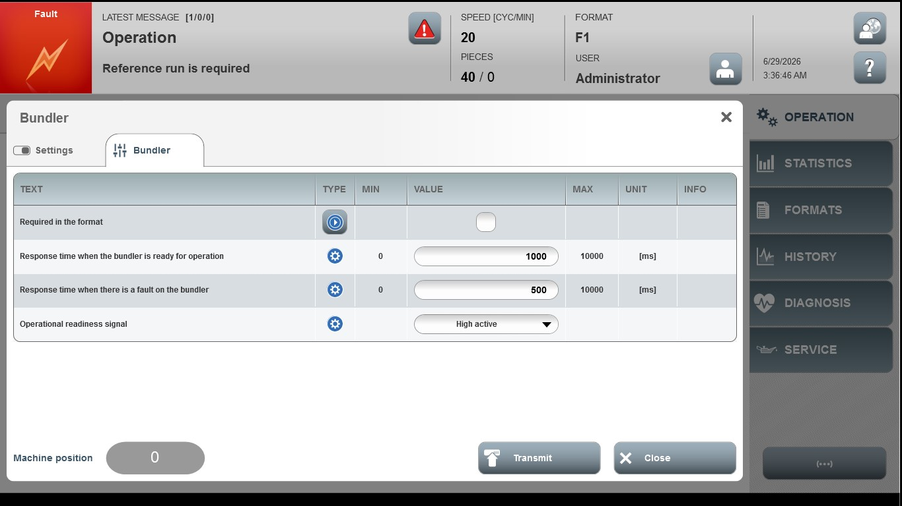
Acceptance criterion | Limits | Pass / Fail: Dev-No. | Date | Initials
Screen matches screenshot | N / A
Response time the bundler is ready for operation | 0…10000
Response time when there is a fault on the bundler | 0…10000

